Cyngor Eglwysi Rhyddion Cymru
Mae Cyngor Eglwysi Rhyddion Cymru yn cynnwys cynrychiolwyr o Undeb yr Annibynwyr Cymraeg, Undeb Bedyddwyr Cymru, Undeb Bedyddwyr Prydain, Eglwys Bresbyteraidd Cymru, yr Eglwys Ddiwygiedig Unedig yng Nghymru, y Gynghrair Gynulleidfaol yng Nghymru, yr Eglwys Fethodistaidd yng Nghymru, Byddin yr Iachawdwriaeth yng Nghymru a Y Cynulleidfaoedd Lutheraidd,Diwygiedig ac Unedig Almaeneg eu hiaith yng Nghymru. Rhyngddynt, mae gan yr enwadau hyn rhyw 65,000 o aelodau mewn 1,600 o eglwysi ledled Cymru, yn addoli trwy gyfrwng y Gymraeg a’r Saesneg.
Yn ei gyfarfod ar Fai 16eg 2017 sefydlwyd Mr Rheinallt Thomas yn Lywydd newydd Y Cyngor am y dair blynedd nesaf. Arweiniwyd y seremoni gan y Llywydd presennol, Y Parch Peter Dewi Richards, ac wrth gyflwyno Mr Thomas nododd nifer o ffeithiau o’i gefndir gan gynnwys iddo fod yn Flaenor gyda Eglwys Brsbyteraidd Cymru ers 1966; yn Gyn Lywydd Cymdeithasfa’r Gogledd a Henaduriaeth Môn a Chyngor Eglwysi Rhyddion Y Gogledd. Nododd ei fod wedi bod yn gyfrifol am Faterion Addysg Cyngor Eglwysi Rhyddion Cymru am 16 mlynedd ac hefyd mai ef oedd Cyfarwyddwr (cyntaf) Canolfan Genedlaethol Addyg Grefyddol am 21 mlynedd. Wedi arwisgo’r Llywydd newydd a chyflwyno y tlws iddo offrymwyd gweddi gan un o gyn lywyddion y Cyngor Y Parch Gareth Morgan Jones.
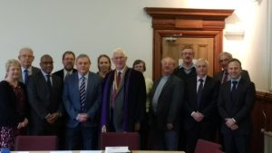
Diolchodd y llywydd newydd i’r Parch Peter Dewi Richards am ei arweiniad doeth a chadarn yng nghyfarfodydd Y Cyngor dros y tair blynedd diwethaf a’i fod fel cyn Ysgrifennydd i’r Cyngor wedi gallu dod a llawer o brofiad i’r swydd. Diolchodd iddo hefyd am weithredu ar ein rhan fel cynrychiolydd yn genedlaethol yn y cyswllt cyhoeddus a’r byd eglwysig.
Aeth Y Llywydd ymlaen i ddiolch am yr anrhydedd a osodwyd arno a hyderai y byddai yn gallu cyflawni gofynion y swydd gyda’r un trylwyredd ac effeithiolrwydd ag a gafwyd gan ei rhagflaenwyr. Gwyddai mai ef oedd y lleygwr cyntafi fod yn Llywydd yn y Gogledd yn 2002 a hyd y gwyddai yr unig leygwr arall i’r Cyngor Cenedlaethol oedd Y Barnwr Dewi Watckin Powell nifer sylweddol o flynyddoedd yn ôl.
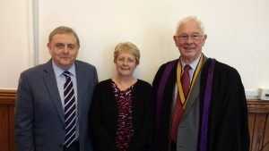
Parch. Peter Dewi Richards; Mrs Helen Jones (Ysgrifenydd); Mr Rheinallt Thomas
The Free Church Council for Wales
The Free Church Council for Wales includes representatives of the Union of Welsh Independents, the Baptist Union of Wales, the Baptist Union of Great Britain, the Presbyterian Church of Wales, the United Reformed Church in Wales, the Congregational Federation in Wales, the Methodist Church in Wales the Salvation Army in Wales and the German-speaking Lutheran, Reformed and United Congregations in Wales. In total, these denominations have about 65,000 adult members in 1,600 churches throughout Wales, worshipping in Welsh and English.
At its meeting on May 16th 2017 Mr. Rheinallt Thomas was installed as President for the next three years. The ceremony was led by the current President, Rev. Peter Dewi Richards, and in introducing Mr. Thomas he noted several facts about background: that he had been an elder of the Presbyterian Church of Wales since 1966; a Past President of the Presbyterian Association in the North; the North Wales Free Church Council and the Anglesey Presbytery . He noted that he had been responsible for the Education Affairs of Free Church Council of Wales for 16 years and also that he was (founder) Director of the Welsh National Centre for Religious Education for 21 years. After the enrobing of new President and presenting him with the chain of office a prayer was offered by a former President of the Council Rev Gareth Morgan Jones.
The new President thanked the Rev. Peter Dewi Richards for his wise but firm leadership at meetings of the Council over the past three years and as a former Secretary to the Council he had been able to bring a lot of experience to the post. He was also thanked for representing us nationally both in the public and church circles.
The President went on to thank for the honour bestowed on him and trusted that he would fullfil the requirements of the post with the same rigor and effectiveness as his predecessors. He knew that he was the first layman to be President in the North in 2002 and to his knowledge the only other lay president of the National Council was Judge David Watckin Powell a considerable number of years ago.
Rev. Peter Dewi Richards; Mrs Helen Jones (Secretary); Mr Rheinallt Thomas

-------------------------------------------------------------------------------------------------------------------------------------
Cyngor Eglwysi Rhyddion Cymru
Mae Cyngor Eglwysi Rhyddion Cymru yn cynnwys cynrychiolwyr o Undeb yr Annibynwyr Cymraeg, Undeb Bedyddwyr Cymru, Undeb Bedyddwyr Prydain, Eglwys Bresbyteraidd Cymru, yr Eglwys Ddiwygiedig Unedig yng Nghymru, y Gynghrair Gynulleidfaol yng Nghymru, yr Eglwys Fethodistaidd yng Nghymru, Byddin yr Iachawdwriaeth yng Nghymru a Y Cynulleidfaoedd Lutheraidd,Diwygiedig ac Unedig Almaeneg eu hiaith yng Nghymru. Rhyngddynt, mae gan yr enwadau hyn rhyw 65,000 o aelodau mewn 1,600 o eglwysi ledled Cymru, yn addoli trwy gyfrwng y Gymraeg a’r Saesneg.
Yn ei gyfarfod ar Mehefin 23ain 2021 sefydlwyd Y Parchedig Simon Walkling yn Lywydd newydd Y Cyngor am y dair blynedd nesaf. Arweiniwyd y seremoni gan y Llywydd presennol,Mr Rheinallt Thomas. Dechreuodd y gwasanaeth drwy air o weddi gan y Llywydd. Darllenwyd rhan o’r ysgrythur o Rhufeiniaid 12: 3 – 13 gan yr Ysgrifennydd ac offrymwyd gweddi gan y Cyn Lywydd Parchg. Peter Dewi Richards.
Gwnaeth y Llywydd Ymadawol ddatganiad o bwrpas y gwasanaeth, sef i sefydlu Parchg. Simon Walkling yn Lywydd y Cyngor am y dair mlynedd nesaf. Gofynnodd y Llywydd i’r Ysgrifennydd i dystio i reoleidd-dra’r penodiad. Atebodd hithau fod y penodiad wedi ei gadarnhau yng nghyfarfod y Cyngor ar 14 Tachwedd 2019. Gofynnwyd cwestiynau i’r Llywydd Etholedig ac wedi cadarnhau eu gweithredu arwisgwyd ef â gŵn a medal ei Swydd. Trosglwyddwyd y Llywyddiaeth i’r Llywydd Etholedig. Gorffennodd y ddefod gyda gweddi’r sefydlu.
Ar ôl y weddi sefydlu, ychwanegodd Simon ei ddiolch i'r rhai a fynegwyd gan aelodau eraill am bopeth yr oedd Rheinallt wedi'i ddwyn i rôl y Llywydd. Dywedodd fod Rheinallt wedi dod â phrofiad ym myd addysg a bywyd capel gyda chyfaredd, argyhoeddiad a gwên. Diolchodd yn arbennig iddo am wasanaethu blwyddyn ychwanegol trwy cyfyngiadau pandemig, pan oedd cyfarfodydd eciwmenaidd wedi lleihau ond roedd yr ymgysylltiad â Llywodraeth Cymru wedi cynyddu.
Nododd Simon fod y darlleniad o Rhufeiniaid 12 yn defnyddio delwedd Corff Crist, a dywedodd fod delwedd Iesu fel y winwydden a ninnau fel y canghennau hefyd yn mynegi ein hundod hanfodol yng Nghrist ac yn dwyn ffrwyth i eraill. Soniodd am waith pwysig y Cyngor wrth fynegi llais anghydffurfiol hynod, yn enwedig ym meysydd caplaniaeth, addysg a datblygiad ysbrydol.
Diolchodd i'r aelodau am roi eu hymddiriedaeth ynddo i fod yn gynrychiolydd effeithiol a gofynnodd am eu harweiniad wrth weithio allan sut mae'r Cyngor yn ffitio o fewn grwpiau eciwmenaidd eraill a sut mae capeli lleol yn cysylltu â gwaith y Cyngor. Roedd yn gobeithio y byddai cyfarfodydd y Cyngor yn datblygu perthnasoedd eciwmenaidd yn ogystal â monitro'r gwaith a wneir rhwng cyfarfodydd. Awgrymodd y gallem ddysgu oddi wrth ein gilydd am addoliad a disgyblaeth ‘Zoom’, ac archwilio posibiliadau o weithio’n eciwmenaidd ar-lein.
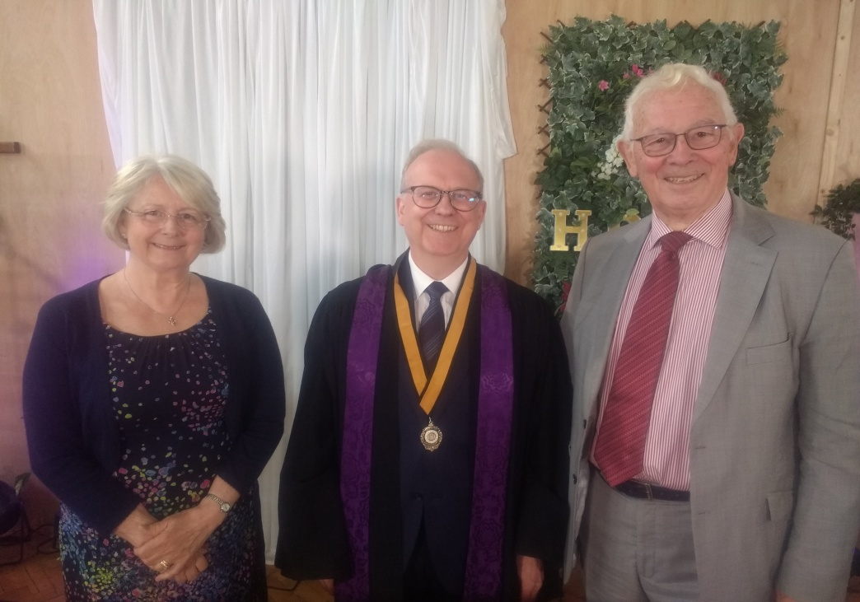
Mrs Helen Jones (Ysgrifennydd); Parchedig Simon Walkling a Mr Rheinallt Thomas
---------------------------------------------------------------------------------------------------------------------------------------------------------
The Free Church Council for Wales
The Free Church Council for Wales includes representatives of the Union of Welsh Independents, the Baptist Union of Wales, the Baptist Union of Great Britain, the Presbyterian Church of Wales, the United Reformed Church in Wales, the Congregational Federation in Wales, the Methodist Church in Wales the Salvation Army in Wales and the German-speaking Lutheran, Reformed and United Congregations in Wales. In total, these denominations have about 65,000 adult members in 1,600 churches throughout Wales, worshipping in Welsh and English.
At its meeting on June 23rd 2021 Rev Simon Walkling was installed as President for the next three years. The ceremony was led by the current President, Mr. Rheinallt Thomas. The service began with a word of prayer by the outgoing President. A portion of scripture was read from Romans 12: 3 - 13 by the Secretary and a prayer was offered by the immediate Past President Reverend Peter Dewi Richards.

The Outgoing President explained that the purpose of the service was to induct the Revd. Simon Walkling as President of the Council for the next three years. After the Secretary attested to the regularity of the appointment the induction proceeded and the new President was invested with his Office gown and medal. The Presidency was transferred.

After the Induction prayer, the new President added his thanks to those expressed by other members for everything that Rheinallt had brought to the role of President. He said Rheinallt had brought his experience in education and chapel life with charm, conviction and a smile to the role. He particularly thanked him for serving an extra year through the pandemic restrictions, when ecumenical meetings had been reduced but engagement with the Welsh Government had increased.

Simon noted that the reading from Romans 12 uses the image of the Body of Christ, and said that the image of Jesus as the vine and ourselves as the branches also expresses our essential unity in Christ and brings fruit to others. He mentioned the important work of the Council in expressing a distinctive nonconformist voice, particularly in the areas of chaplaincy, education and spiritual development.

He thanked members for putting their trust in him to be an effective representative and sought their support in working out how the Council fits in with other ecumenical groups and how local chapels relate to the work of the Council. He hoped that Council meetings would develop ecumenical relationships as well as monitor the work done between meetings. He suggested that we could learn from each other about worship and the discipline of 'Zoom', and explore the possibilities of ecumenical working online.

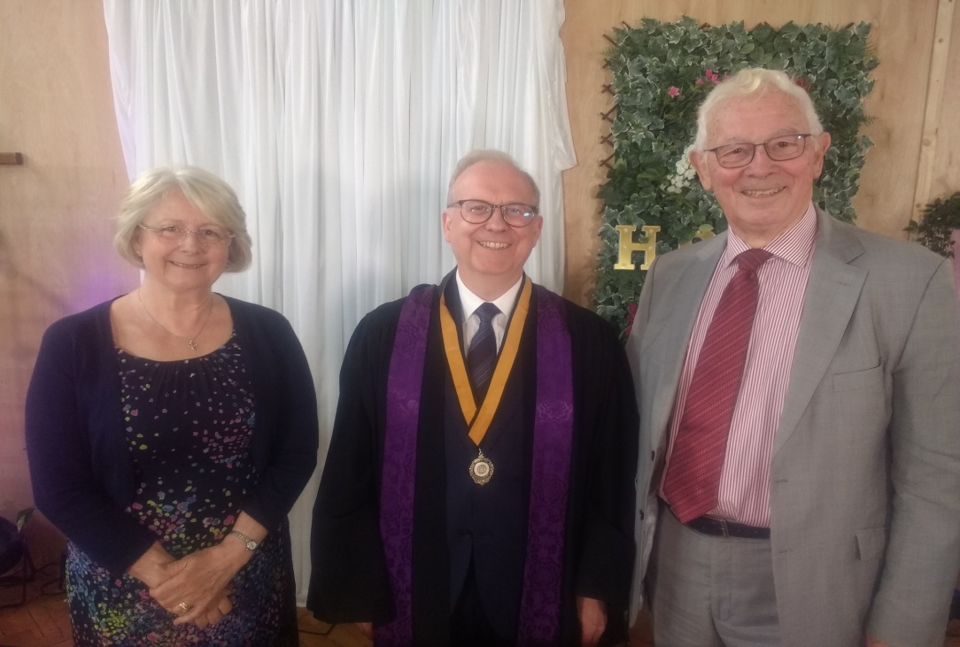
Mrs Helen Jones (Secretary); Revd. Simon Walkling & Mr Rheinallt Thomas

