President’s Diary of Events -Nos 1-3 (May 2017 – April 2018)Download
Dec 19.
Attended a meeting at the Mansion House, at the invitation of Councillor Huw Thomas, Leader of Cardiff City Council, to discuss with other Faith Leaders as to how the Council and the Faith Community can work together to meet the needs of a diverse city. A very interesting and fruitful meeting with Councillors, Chief Executive and ten of us representing a variety of
faiths.
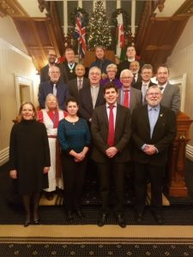
No 3 –(January – March 2018) As can be seen the early months of the year has been much quieter than the previous eight months. Nevertheless the experiences have been varied and extremely interesting and it is a privilege to fly the banner of the Free Churches Council of Wales

﻿ Cyngor Eglwysi Rhyddion Cymru Digwyddiadur Y Llywydd (Mai 2017 i Ebrill 2018)
Rhag.19
o gredoau..

(Rhif 3 – Ionawr-Mawrth 2018) Fel y gwelwch mae misoedd y gwanwyn wedi bod dipyn distawach na’r wyth mis cynt– ond eto profiadau amrywiol a diddorol dros ben ac mae’n fraint cael chwifio baner Cyngor Eglwysi Rhyddion Cymru yn yr amrywiol gyrchfannau

